GRANT YEAR DISPLAYING IN SPREADSHEETS
Any spreadsheet that displays account code will have a ‘NOTE’ with a green background on the settings tab that briefly explains where Grant Year will show in the spreadsheets. | 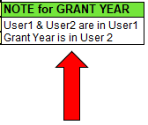
The User2 column data that was previously displayed in a separate column will now be in the User1 column, and the User1 and User2 data will be separated by a dot. | 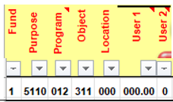
To filter for User1 information, use the dropdown filter option in the User1 column and enter the 3-digit code followed by a dot (.) to see all the accounts with the User1 code. | 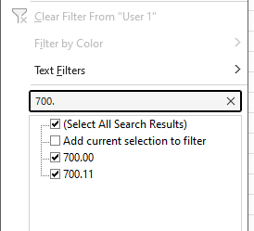
To filter for User2 information, use the dropdown filter option in the User1 column and enter a dot (.) followed by the 2-digit User2 code. | 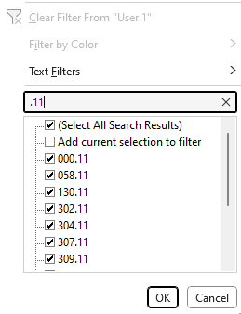
To filter for Grant year information, use the dropdown filter option in the User2 column and enter the desired grant year. | 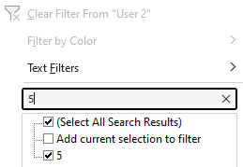
The Helpful Information tab has also been updated to explain where Grant Year will be displayed and how User1 and User2 are displayed in the previously User1 column, where the two are separated by a dot (.).  Note: All previous screenshots in the helpful information tab remain the same in that they show User1 and User2 in separate columns. | 