The spreadsheets have two components to refresh. | Component 1: The Spreadsheet  Component 2: Statements (this is the coding to pull data into the spreadsheet)
4 scenarios can happen during the transition for showing Grant Year in the spreadsheets.  See more information for each Scenario Below. | Scenario One: nothing has changed! The spreadsheet and the data are the same as always.  Scenario Two: The new spreadsheet has NOT been installed, but after refreshing, the User1 and User2 data are in the User1 column, which is not wide enough to see all the data. Grant Year shows in the User2 column.  Scenario Three: The Grant Year Spreadsheets have been installed, but the grant year does not show up after refreshing, and User1 and User2 are still in separate columns, as always.  Scenario Four: Spreadsheets have been installed, and statements have been updated at the district to display Grant Year. This will be the ultimate result for everyone. (See filtering information below)
Scenario One | Old Spreadsheets, old statements
What does Scenario One look like? | Nothing has changed! The spreadsheet and the data are the same as always.
What to do for Scenario One: | Contact support and ask for an installation email for Grant Year. Also, ask when the new statements will be updated at your district for Grant Year.
Scenario Two | Old Spreadsheets, new statements
What does Scenario Two look like?  The settings tab does not have a ‘NOTE for grant year’; however, after refreshing, Grant Year shows in User2 column, but User1 column is not wide enough to show all the data.  Also, no comments are tied to User1 and User2 columns. (see comments information in Scenario Four) | 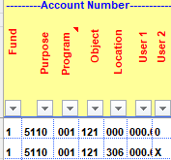
What to do for Scenario Two: | Contact support and ask for an install email for Grant Year.
Scenario Three | New Spreadsheets, old statements
What does Scenario Three look like?  The Grant Year Spreadsheets have been installed and the ‘Note for Grant Year’ is on the settings tab, but the Grant Year data is NOT displaying. | 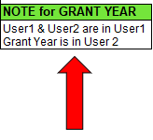
No Grant Year in User2. The data looks the same except User1 column width is wider and the comments are tied to User1 and User2. (see comments information in Scenario Four) | 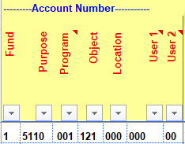
What to do for Scenario Three: | Contact support and ask when the new statements will be updated at your district for Grant Year
Scenario Four | New Spreadsheets, new statements
What does Scenario four look like? (Ultimate Result)  New spreadsheet has been installed and Grant Year is showing in User2 column. User1 and User2 are showing in User1 column separated by a dot (.) | 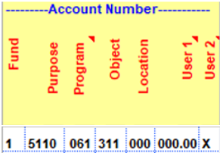
Settings tab will have a Grant Year Note. | 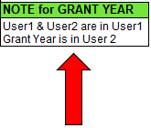
Working Tab (example Budget)  User1 column will be expanded to show User1 data, dot (.), User2 data  User2 column will contain Grant Year data | 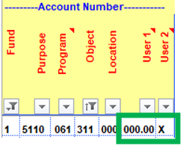
To filter for User1 information, use the dropdown filter option in the User1 column and enter the 3-digit code followed by a dot (.) to see all the accounts with the User1 code. | 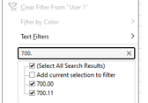
To filter for User2 information, use the dropdown filter option in the User1 column and enter a dot (.) followed by the 2-digit User2 code. | 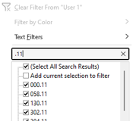
To filter for Grant year information, use the dropdown filter option in the User2 column and select the desired grant year. | 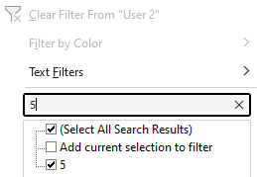
Comments are tied to User1 column. To see this comment, hover over the User1 column heading. | 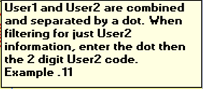
Comments are tied to User2 column. To see this comment, hover over the User2 column heading. | 
What to do for Scenario Four: | Nothing – everything has been done!

