How to Remove Rows from a Pivot Table

Information in a Pivot Table is generated from the original tab refreshed to retrieve information from your Financial system.

You cannot delete rows of information in a Pivot Table – you will receive this message if you try to delete.

There are two methods you can use to remove rows from a Pivot Table

- Hide Rows
Right Click on the row(s) to be deleted from your view, select Hide
Example below, I selected row 27 to hide.
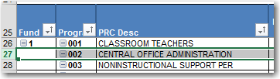
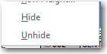
As you can see, Row 26 is now hidden from my view. The information is still there, it is just hidden. Pivot Table will reset once you close your spreadsheet.
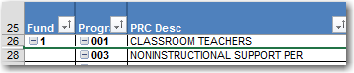

To unhide the rows, highlight the rows showing, and select unhide. In this example, row 27 will return to your view.

- Remove row information
In this example, I want to remove PRC 002 that is on row 27.

Return to your main tab with your retrieved data, Filter for PRC 002
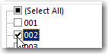

Highlight the rows with PRC 002 information, right-click and select Delete Row.
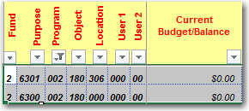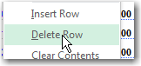

You now have adjusted your original data.

Return to the Pivot Table and select Refresh Data button. This will update your Pivot Table with the information that you have removed from the original tab.


