New Features for Budget with Details.
All Purpose Codes option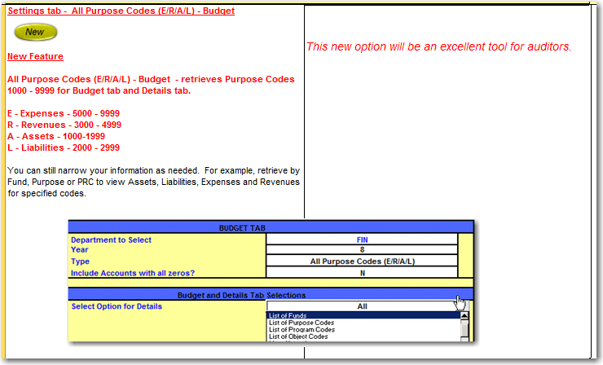
Object Code option updated to show 000-999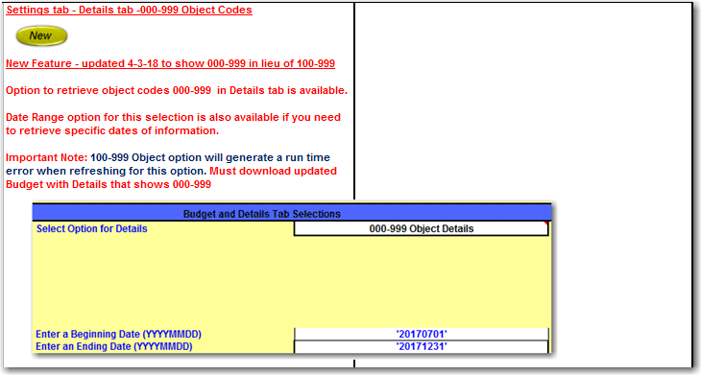

New Pivot Table Button for all account code fields.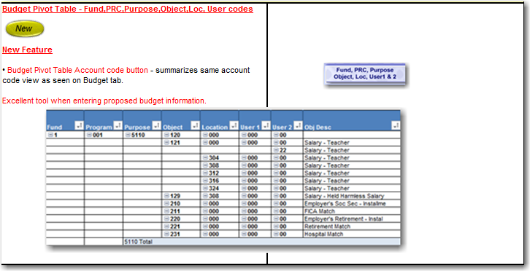
New Pivot Table Button to include Expenses for Budget Yr-Yr Compare