How to create Multiple Year data for Payroll History spreadsheet
Option 1 – using Date Range. (Large districts may want to use Option 2 in this document)
Retrieve data for 3 years  - Select Date Range on Settings Tab  - Enter dates for 3 years – i.e. 20130701 to 20160630 and Refresh Data  (Large districts may want to use Option 2 in this document due to large amount of data) | 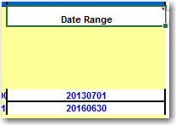
Save Spreadsheet  - Select File, Save AS and save spreadsheet as another Name i.e. Payroll History with Multiple Years for Teachers. Save the document into another folder on your desktop. | 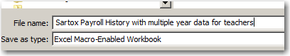
Deleting object codes  - Because Date Range retrieves all codes, the next step is to delete object codes that you do not want in your report.  - Click on drop down filter on Object column, remove the check mark for object codes 121 through 125 (this will be object codes for teachers that you will want to keep in your report). | 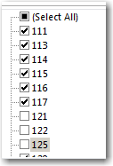
- You will now see all object codes except for the teacher codes that you removed the check mark.  - Click in the first cell with data and highlight all rows of data within the spreadsheet (hold shift key down, select the END key and then right arrow key. Still holding shift key down, select END key again and select the down arrow key). This will highlight all the rows that you will want to delete.  - Right-click in the highlighted area, select Delete Row and OK to Delete entire sheet row | 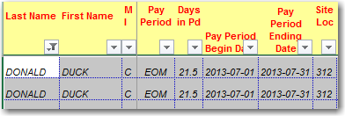  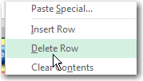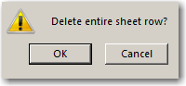
- You may receive this message. Just select OK
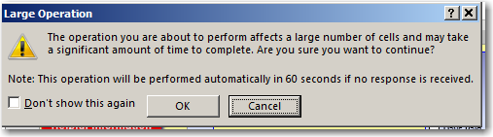

- Spreadsheet will show blank rows. Click on Object column filter and select the Select All for object codes 121-125 (teacher codes). Scroll to top of spreadsheet to see data. Click on Save again to ensure you keep just the codes you need for your report.
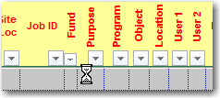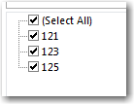

- Next, you will want to add a Fiscal Year column heading at the end of the spreadsheet data. Just scroll to end of columns and type Fiscal Year in the first blank column |  | 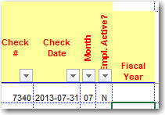
- You will now need to select the check dates within each fiscal year.  Click on drop down filter in the Check Date column. Click in the Select All cell to remove all filters from check dates. Then select the check dates within the first fiscal year data (this example is from July 2013 to June 2014).  - Type 13-14 in the first cell of the Fiscal Year column you created at end of the spreadsheet.  - Click on the cell and select copy for the 13-14 cell. Highlight the remaining empty cells and paste 13-14 into those cells. |  | 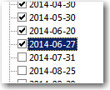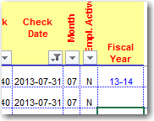  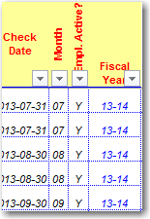
- Repeat this for each fiscal year (example: 14-15 and 15-16)
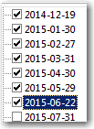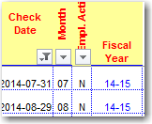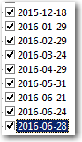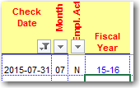

You have now entered the fiscal year beside each appropriate check date.

Now you are ready to use your Pivot Table to summarize your data.

PIVOT TABLE – use your Pivot Table to summarize your data.
- You will need to refresh your Data in the Pivot Table to show teacher object codes only and the new column you created for Fiscal Year.  - Click on the Refresh Data button in the Pivot Table | 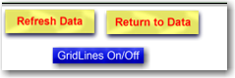
Arrange Pivot Table  - Click on the Full Account with Names Pivot Table button. If you do not want to show the Full Account Code, drag this to the top of your Pivot Table.  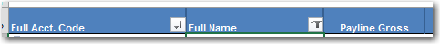   | 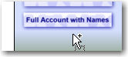

Remove any column headings that you do not need

If you want just the Payline Gross column in your Pivot Table, left click and drag remaining columns in the calculated section off the Pivot Table. A red X will show when dragging. The X means than you can’t drag to the top of the filtered portion of the Pivot Table but it will remove the columns.

How to add the Fiscal Year column you created on the main Payroll History tab to the Pivot Table

- The Fiscal Year column added to the Payroll History tab will show in the Field List. Right-click inside the Pivot Table view and select Show Field List.
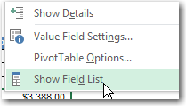

- Scroll to bottom of Field List to see Fiscal Year. To add this column to your Pivot Table, click inside the box. This will automatically go into your Pivot Table.
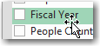

- If you would like the Fiscal Year to display horizontally, left-click on Fiscal Year heading and drag over the Payline Gross column heading.
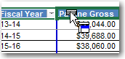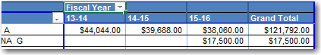

Your View will look like this. Important: remove all columns to the right of Payline Gross before dragging Fiscal Year on top of the Payline Gross heading.

How to Save Pivot Table Information
- Save your spreadsheet.

- Important: If you want to send this information to someone, you will need to copy and save the Pivot Table information to a blank Excel worksheet.

- The Pivot Table contains all columns from the main tab and cannot be deleted so it is best to highlight and copy the rows of information to a blank Excel worksheet.

- If you copy the Pivot Table to a blank Excel worksheet, a user will be able to drag any of those fields into the Pivot table to see information. You would not want to have SSN, etc available for viewing.

- Save the new excel workbook with Pivot Table information.

This is a view with data copied from a Pivot Table into an Excel Spreadsheet. You will need to adjust width of column headings

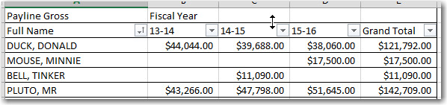

Option 2 – retrieve data by account codes to create multiple years of information. (Large districts may want to use this option due to large data))
- The objective is to retrieve 3 years of data, but retrieve one year at a time and build 3 years of information into a saved spreadsheet.

- Select the first year of data to retrieve on the Settings tab. (this example is year 13-14)
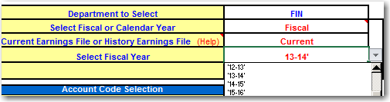

- Select List of Object codes (or whatever codes you wish to retrieve) on Settings Tab


- Enter object codes – and Refresh Data (in this example is for teacher object codes.) | 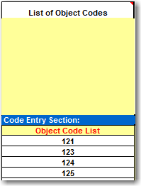
- Once data is retrieved, you will want to add a column titled Fiscal Year at the end of the spreadsheet data.  - Enter year of data retrieved in the first cell under Fiscal Year. (this example is 13-14 fiscal year). Select Copy  - Highlight cells to end of data and select Paste to copy year 13-14 for each row of data.  - Save spreadsheet again with year 13-14 Fiscal Year data. | 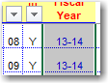
- Use original Payroll History spreadsheet and retrieve data for 14-15 for object codes 121-125. (second year of data).

- Once retrieved, it is important to unhide Column A in order to highlight and copy ALL columns (including hidden columns) in the spreadsheet for year 14-15 and copy to saved spreadsheet. IMPORTANT: before pasting info into saved spreadsheet, UNHIDE Column A.

If you copy without including all columns, your Pivot table information will look like this because the Full Name that is hidden on the original view of your Payroll History would not be included.
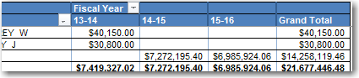

- Easy way to unhide Column A is to select SSN in the Show/Hide box. | 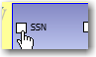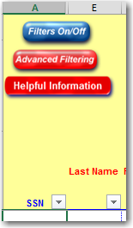
- When you unhide Column A and you highlight rows to copy, you will also include the column with the Full Name which must be copied so that the Pivot Table information will display correctly.

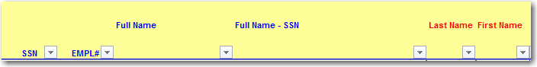

Copy Year 14-15 information from original spreadsheet into your saved spreadsheet.  - After you have highlighted your information in the original spreadsheet and selected Copy, click in the first empty cell at the bottom of Column A in the saved spreadsheet and select Insert Copied Cells.  This is important so that the Totals are moved down as new data is inserted. | 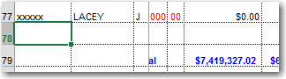  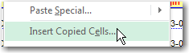  You will receive option to Insert – select the Shift cells down.  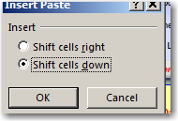
- Repeat procedures above – type 14-15 into Fiscal Year column and then copy down to end of data. Highlight empty cells and then paste 14-15 into column.
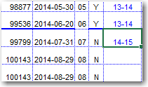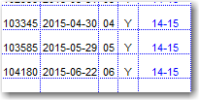

- Repeat for the 3rd year of information. Year 15-16

- You will need to refresh data in the Pivot Table to show the Fiscal Year column and dates you typed in the cells on the main tab.

PIVOT TABLE – use your Pivot Table to summarize your data.
- You will need to refresh your Data in the Pivot Table to show the Fiscal Year column and dates you typed in the cells on the main tab.

- Click on the Refresh Data button in the Pivot Table

Arrange Pivot Table

- Click on the Full Account with Names Pivot Table button. If you do not want to show the Full Account Code, drag this to the top of your Pivot Table.

Remove any column headings that you do not need

If you want just the Payline Gross column in your Pivot Table, left click and drag remaining columns in the calculated section off the Pivot Table. A red X will show when dragging. The X means than you can’t drag to the top of the filtered portion of the Pivot Table but it will remove the columns.
How to add the Fiscal Year column you created on the main Payroll History tab to the Pivot Table

- The Fiscal Year column added to the Payroll History tab will show in the Field List. Right-click inside the Pivot Table view and select Show Field List.

- Scroll to bottom of Field List to see Fiscal Year. To add this column to your Pivot Table, click inside the box. This will automatically go into your Pivot Table.

- If you would like the Fiscal Year to display horizontally, left-click on Fiscal Year heading and drag over the Payline Gross column heading.

Your View will look like this. Important: remove all columns to the right of Payline Gross before dragging Fiscal Year on top of the Payline Gross heading.

How to Save Pivot Table Information
- Save the spreadsheet again that you have entered the Fiscal Year column.

- Important: If you want to send this information to someone, you will need to copy and save the Pivot Table information to a blank Excel worksheet.

- The Pivot Table contains all columns from the main tab and cannot be deleted so it is best to highlight and copy the rows of information to a blank Excel worksheet.

- If you copy the Pivot Table to a blank Excel worksheet, a user will be able to drag any of those fields into the Pivot table to see information. You would not want to have SSN, etc available for viewing.

- Save the new excel workbook with Pivot Table information that you copied..

This is a view with data copied from a Pivot Table into an Excel Spreadsheet. You will need to adjust width of column headings

