Table of Contents
Budget Summary and Board Report 2
How to view Purpose Code Report with 1 digit, 2 digit or 3 digit codes and description 2
How to view Object Code Report with 1 digit or 2 digit codes and description 3
How to easily manage DashBoard views for Budget Summary and Board Report 4
Budget Allocations Dashboard 4
Budget Allocation – Purpose (2 digits) 4
The graphs/charts are interactive! You can use the selection boxes (slicers) to change the graphs. 5
Example of selecting slicers 6
Budget Expenses 7
Expenses by Object (2 digit) Slicer 8
Tips for working with the 2 digit Object Slicer 8
How to select multiple slicers (same as filtering) 10
How to remove slicers (filters) 10
How to Change Charts/Graphs from percentage to dollar value 11
Format value numbers to Currency: 11
Resize charts 12
Copy charts to Word or Power Point 12
Copy DashBoard tab to a new excel book: 13
Compare current year to prior year(s) data 14

Budget Summary and Board Report

How to view Purpose Code Report with 1 digit, 2 digit or 3 digit codes and description
Refresh the Board Report with options of your choice on the Settings Tab. | 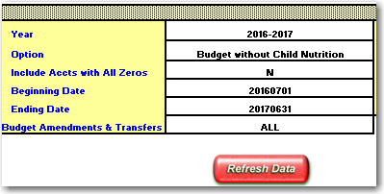
On the Budget Summary & Board Report tab, click on any button that has Purpose in the description.  I selected the Expenses by Fund and Purpose only for this example. | 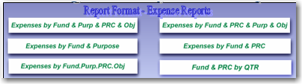
Select the format for the purpose code (you can select any of the options, depending on the level of detail that you need for the purpose codes.) In this example, I selected a 1-digit purpose code (i.e. 5XXX) | 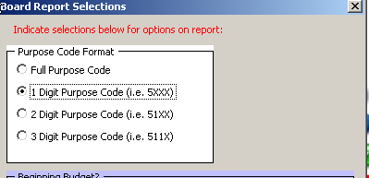
The report will look similar to this. | 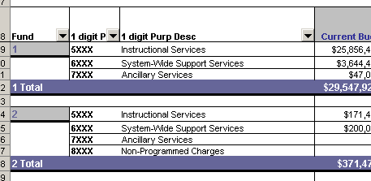

How to view Object Code Report with 1 digit or 2 digit codes and description

1 and 2 Digit Object and Object Description is available in the top filter section on the Pivot Table  Drag down to the Pivot Table  I selected the Fund & PRC & Purp & Obj for this example. | 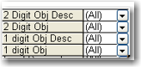  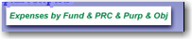
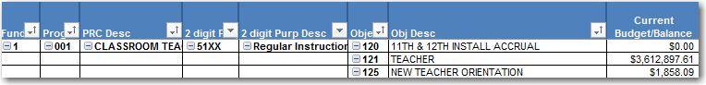
Drag 1 or 2 Digit Obj into the table. I placed in front of the Object column.
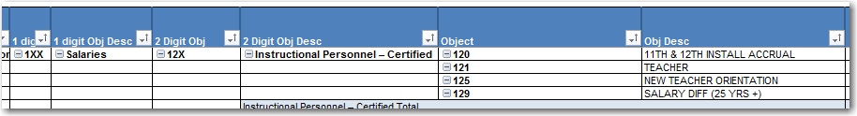
As you move and add columns within a Pivot Table, subtotals may need to be removed or added.  If there is an extra subtotal in the 1 digit Obj column. Right click on this column and select Field Settings | 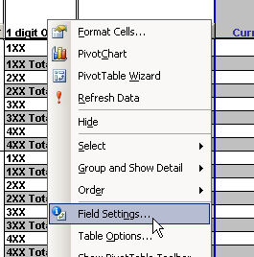
Set the Subtotals to None | 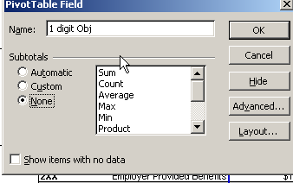

How to easily manage DashBoard views for Budget Summary and Board Report
The new Budget and Board Report contains several dashboards that will give you graphical access to your budget and expense information. The charts are easily accessible from buttons on the Settings tab and Budget Summary and Board Report tab. | 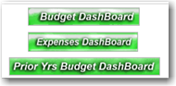  Refresh Data prior to using buttons on the Settings Tab or Budget Summary and Board Report Tab

Budget Allocations Dashboard

Charts display by Purpose and Object (1 digit). Budget and Remaining Balance graph displays.
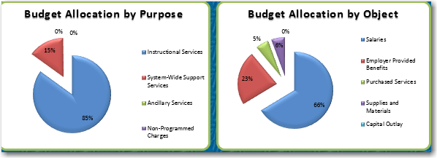
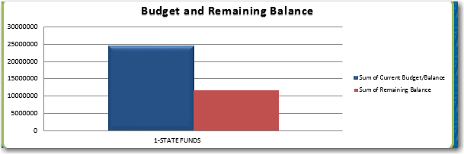

Budget Allocation – Purpose (2 digits)
Chart also displays for Detailed Purpose (2 digits)
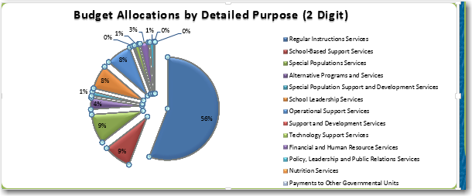

The graphs/charts are interactive! You can use the selection boxes (slicers) to change the graphs.

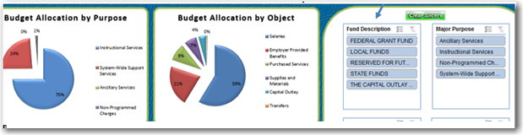

Note: Slicers are basically the same thing as filters. As you select a slicer, selections for additional slicers (filters) change according to selection

For example, if you want to see only Local Funds in the graphs, you would select Local Funds in the Fund Slicer. This will change the graphs to show the allocation by major purpose code (5xxx etc) and by Object.

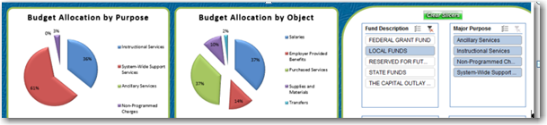

Example of selecting slicers
As you select a slicer (filter) selections for additional slicers (filters) change according to selection and move to the top highlighted in blue  I selected Fund 7.  Notice Program Description now only has After School Care and Supplementary Services available at the top.  Purpose Description has 3 descriptions listed at the top.  Location is also showing only the locations that apply to Fund 7.  As you drill down by selection slicers in each box, options change accordingly. | 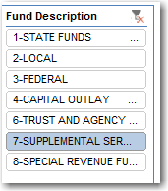  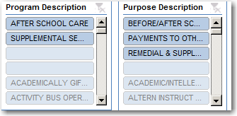  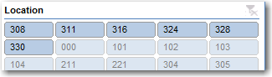

Budget Expenses
Charts display for Purpose and Object (1 Digit)
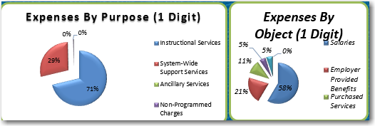

Charts display for Purpose and Object (2 Digits)
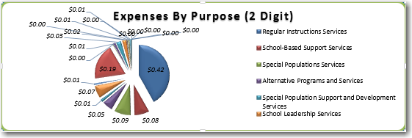
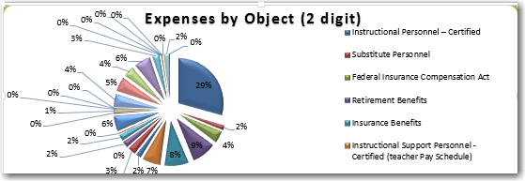

Expenses by Object (2 digit) Slicer
Expenses by Object (2 digit) is an additional Slicer to drill down information as needed.  NOTE:  The descriptions in this box remain the same – they do not change as you select slicers from Fund, Major Purpose, Program Description, etc. | 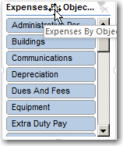

Tips for working with the 2 digit Object Slicer
Tip #1
Clear Slicers and select a description in the Expenses by Object box. Fund, Purpose, etc will automatically adjust for your selection as well as the charts. You can then drill down the slicers as needed for Fund, Major Purpose, etc.
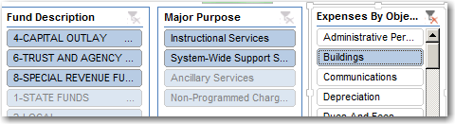
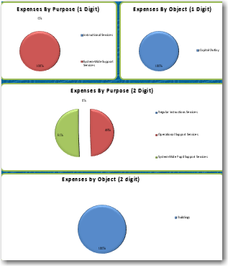
Expenses show 100% due to one selection in the Object Slicer.

Tip # 2
Select a description from the Chart for Expenses by Object (2 digit) that you would like to view only that item.

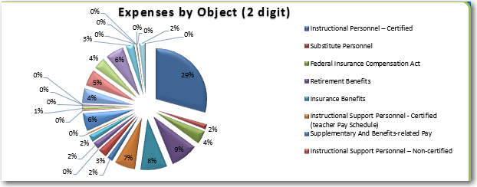

Example: Instructional Personnel – Certified is showing in the Object (2 digit) chart. To view just the Instructional Personnel – Certified as main selection, click on this title in the Expenses by Object (2 digit) Slicer box.  Charts adjust according to your selections.  You can continue to drill down with the slicers for the Fund, Purpose, etc  I selected Federal as an additional slicer. See Chart change  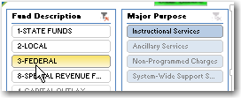  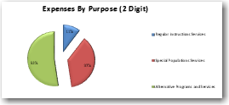 | 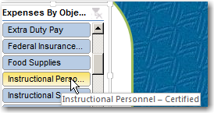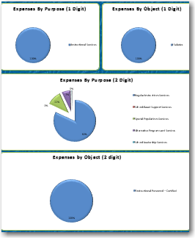

How to select multiple slicers (same as filtering)
To select multiple slicers, click on the first selection (i.e. Ancillary Services)  Hold Control Key down (Ctrl key) and click on next selection – i.e. Instructional Services.  Multiple selections will be highlighted in blue.  Scrolling will be necessary in some boxes to select multiple choices. | 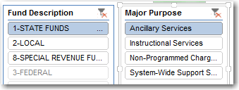  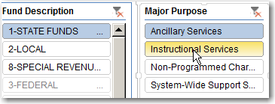  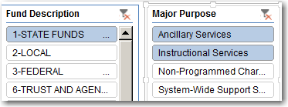  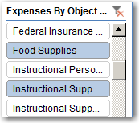

How to remove slicers (filters)
As you select choices within your Slicers, a filter icon appears at the top of the box to show that you are filtered or have made selections.  To return to all selections in a particular box, click on the filter icon and all selections will appear.  To reset all boxes – select Clear Slicers | Notice the filter Icon has a red x below it.  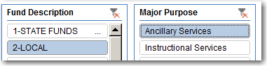  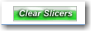

How to Change Charts/Graphs from percentage to dollar value
Dashboard has been set to show as Percentage.  To change to a value in lieu of percentage:  Right click inside the Chart Area, select Format Data Labels  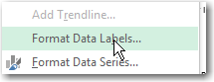  Format Data Labels displays on the right side. Select Value to change chart to numbers in lieu of percentage.  Format value numbers to Currency:  - Click on the arrow for NUMBER to display options  - Click on drop down arrow in the Category box and select Currency.  - Set Decimal Places and Symbol to be $.  My Chart now displays in Currency  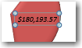 | 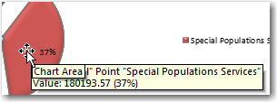  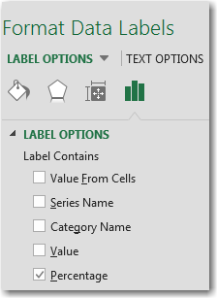  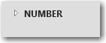  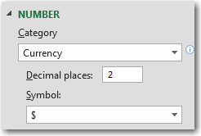

Resize charts
Click inside the white area of the chart to place the box in an edit view.  Sizer handles appear around the edge of the Chart View.  Click and drag on one of the corner handles to size the chart – smaller or larger | 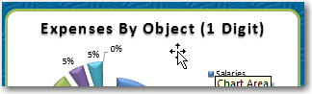  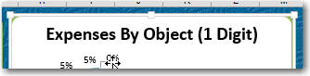  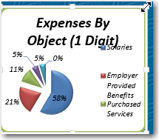

Copy charts to Word or Power Point
Select the Charts you wish to copy – click inside the white area of the chart table, Right-click, select copy.  Open document you wish to insert charts and Right-click, select paste. | 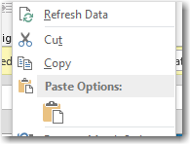  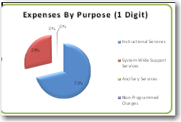

Copy DashBoard tab to a new excel book:
Copy DashBoard tab to a new excel book:  Right-click on DashBoard Tab (Expense Dashboard)  Select Move or Copy  Place check mark in Create a copy  Click on drop down filter in Move selected sheets To book:  Select (new book) or Excel document of your choice. Click OK  Tab will appear in your own Excel document.  Tip:  Once you copy a dashboard tab to a new document, the slicers will no longer function. Suggest you select Slicers prior to copying dashboard tab so that your selections display correctly. | 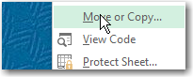  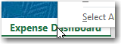  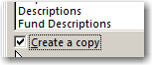  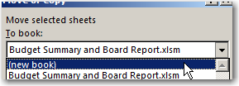  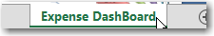

Compare current year to prior year(s) data
The Prior Years Dashboard compares summary budget information from the current year with the previous year and 2 years ago:  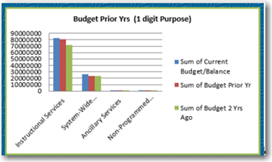  Remember to select a Y for account codes without dollar activity on the Settings Tab to retrieve any codes from prior years that may not have activity in current year.  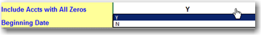 | These charts also have slicers to select the criteria for the charts:  