Checking Version of Excel:
Three methods of finding the version of Excel on your PC.
- Search for excel.exe – open file location
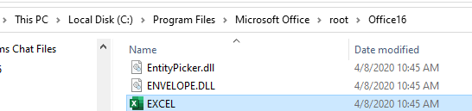
Right mouse click, choose properties. This is version of excel, and last date updated.

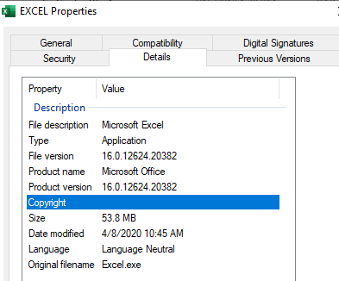

2. Open blank Excel document:
File, Account
This is Paige’s PC screenshot below:
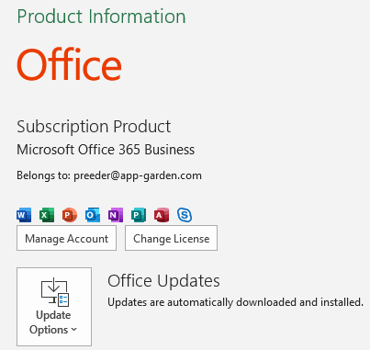


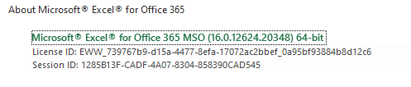
The above screen is not necessarily accurate.
Control panel and first method are.

3. Control Panel
