How to create 4-Digit SSN repot
Click on the 4 Digit SSN button on the Payroll History main tab. | 
The SSN column will format to show only the last 4 digits. (note: this button only reformats the SSN column.  (The Full Name with SSN column does not reformat with 4 digits at this time - we will look at updating the spreadsheet to format this column as well.) | 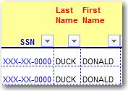
Click on the Payroll History Pivot Table tab. Click on the Refresh Data button in your Pivot Table to update Pivot Table with the SSN formatted to show 4 digits. | 
The SSN is not listed in the Pivot Table view. To add SSN, right-click inside the Pivot Table, select Field List to display all of the column headings that are available in the Payroll History spreadsheet. | 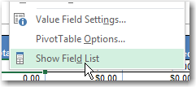
SSN field is at the top of the list. Click in the check box and the SSN field will automatically display as the last field in your Pivot Table view | 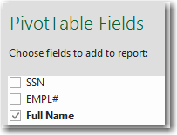    
The Full Account with Names view is a good start for Pivot Table view. Then add the SSN per instructions above. Drag off account code if you do not need this field and you will have a listing of all employees with 4-digit SSN. |   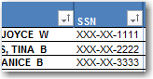

Close spreadsheet and refresh to reset SSN back to original format of all numbers and dashes.

